COMBO DEMONSTRATION REPORT – 1
Seed to Harvest
Details Of Farmer
Name of Farmers | Atal bihari
Mobile No. | 7654878082
Village Name | Nawadih
Block & Tehsil | Tilouthu
District & State | ROHTASH

Field And Crop Detail
Total Acreage(acre) | 15 ACRE
Crops Grown | 15 ACRE
Field Location (Easy approach/road side) | ROAD SIDE
Selected - Crop & Variety | PADDY MTU-7029
Trial Plot Area (KATHA) | 18KATHA (INCULDING T1+ T2+ T3)
Seed Rate (kg/acre) | 3 KG/ACRE
Sowing Date | 15.07.2025

Demo Product Name And Dose& Field day detail
Name of Product | SULFINO GOLD
Application Dose (ml/acre) | 600 Gm
Date/Time of Application | 22.08.2025
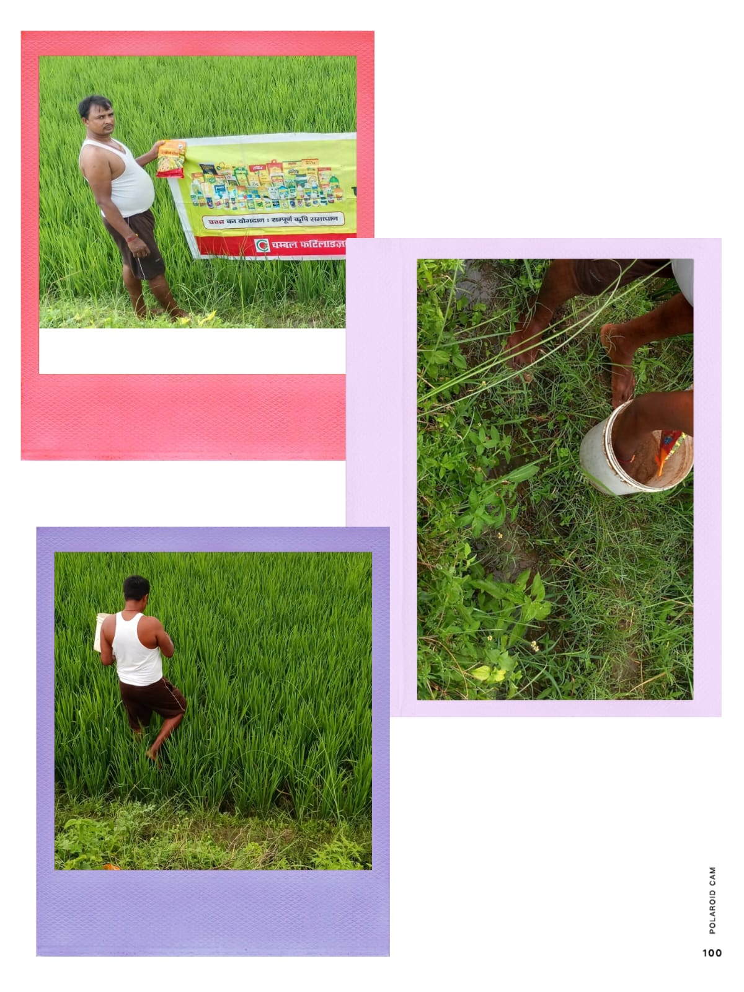

COMBO DEMONSTRATION REPORT – 2
Seed to Harvest
Details Of Farmer
Name of Farmers | Narendra Singh
Mobile No. | 9507174853
Village Name | Huruka
Block & Tehsil | Tilouthu
District & State | ROHTASH

Field And Crop Detail
Total Acreage(acre) | 12 ACRE
Crops Grown | 12 ACRE
Field Location (Easy approach/road side) | ROAD SIDE
Selected - Crop & Variety | PADDY MTU-7029
Trial Plot Area (KATHA) | 24KATHA (INCULDING T1+ T2+ T3)
Seed Rate (kg/acre) | 3 KG/ACRE
Sowing Date | 15.07.2025

Demo Product Name And Dose& Field day detail
Name of Product | SULFINO GOLD
Application Dose (ml/acre) | 7.50 GM
Date/Time of Application | 26.08.2025
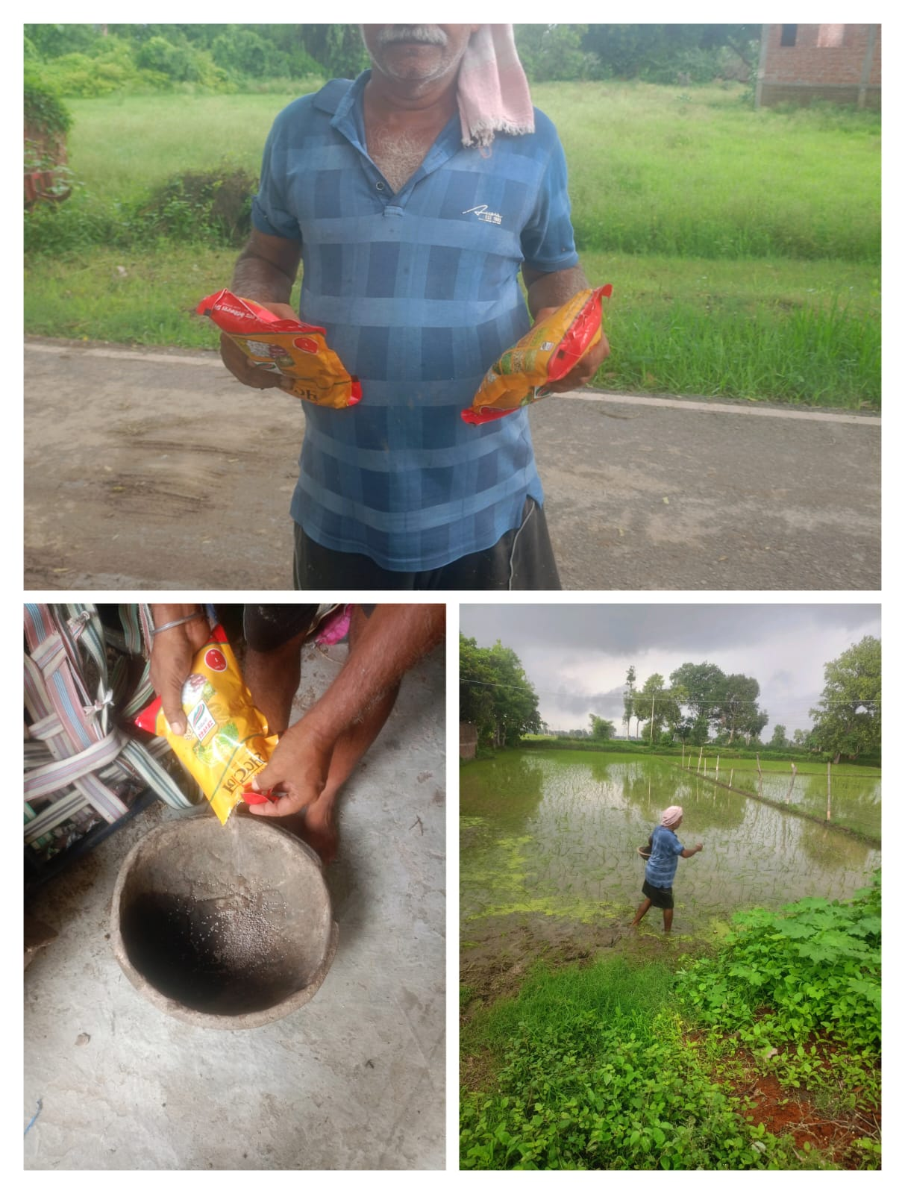

COMBO DEMONSTRATION REPORT – 3
Seed to Harvest
Details Of Farmer
Name of Farmers | Virbahdurupadhyay
Mobile No. | +919525592298
Village Name | Sewahi
Block & Tehsil | Tilouthu
District & State | ROHTASH

Field And Crop Detail
Total Acreage(acre) | 8 ACRE
Crops Grown | 8 ACRE
Field Location (Easy approach/road side) | ROAD SIDE
Selected - Crop & Variety | PADDY MTU-7029
Trial Plot Area (KATHA) | 32 KATHA (INCULDING T1+ T2+ T3)
Seed Rate (kg/acre) | 3 KG/ACRE
Sowing Date | 18.07.2025

Demo Product Name And Dose& Field day detail
Name of Product | SULFINO GOLD
Application Dose (ml/acre) | 1.5 KG
Date/Time of Application | 27.08.2025
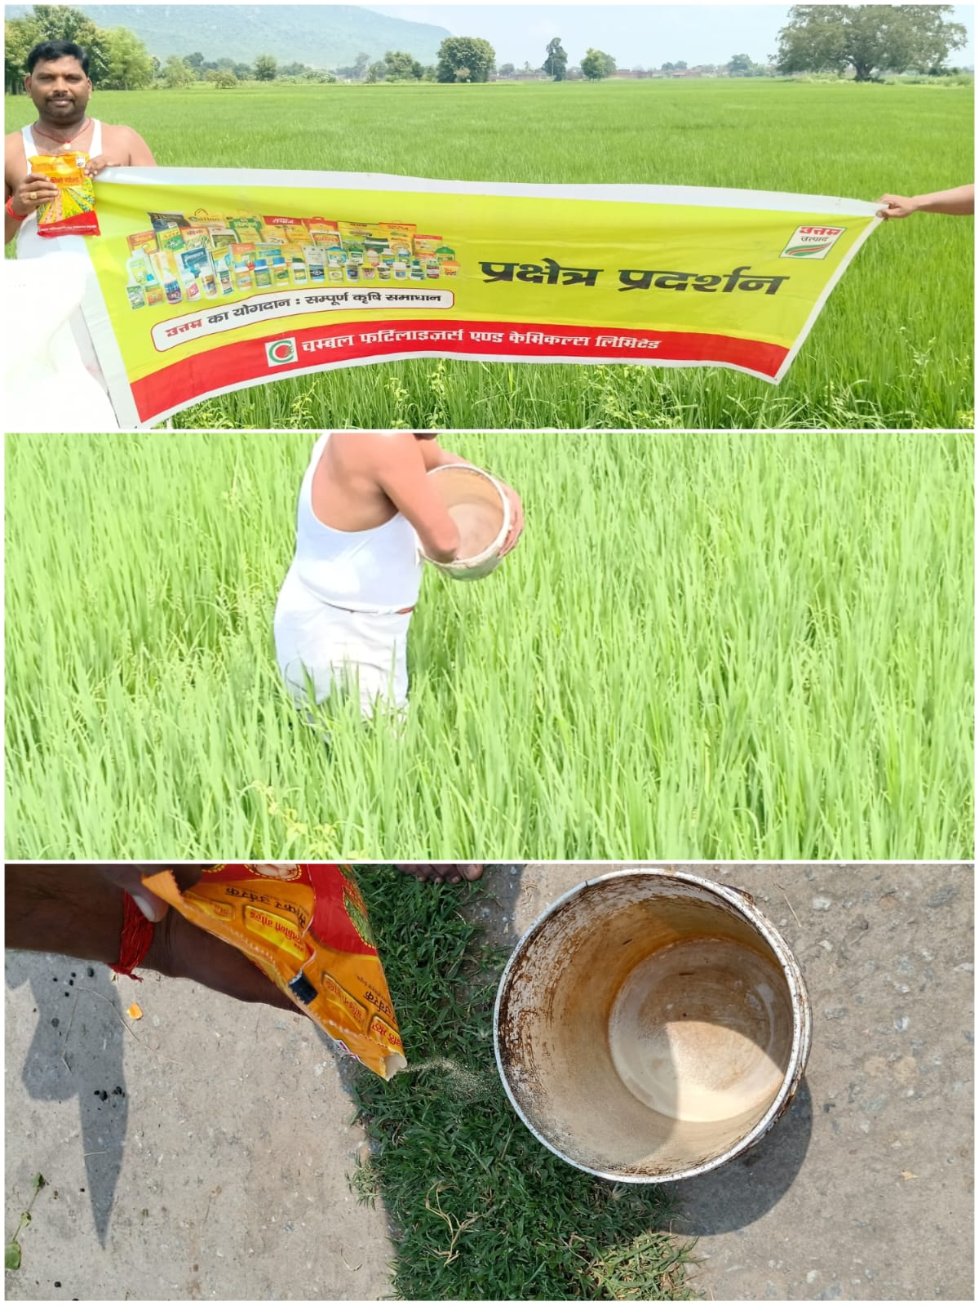

COMBO DEMONSTRATION REPORT – 4
Seed to Harvest
Details Of Farmer
Name of Farmers | Munna dube
Mobile No. | 6204918844
Village Name | Harnachiti
Block & Tehsil | Tilouthu
District & State | ROHTASH

Field And Crop Detail
Total Acreage(acre) | 15 ACRE
Crops Grown | 15 ACRE
Field Location (Easy approach/road side) | ROAD SIDE
Selected - Crop & Variety | PADDY MTU-7029
Trial Plot Area (KATHA) | 18KATHA (INCULDING T1+ T2+ T3)
Seed Rate (kg/acre) | 3 KG/ACRE
Sowing Date | 19.07.2025

Demo Product Name And Dose& Field day detail
Name of Product | SULFINO GOLD
Application Dose (ml/acre) | 600 GM
Date/Time of Application | 28.08.2025
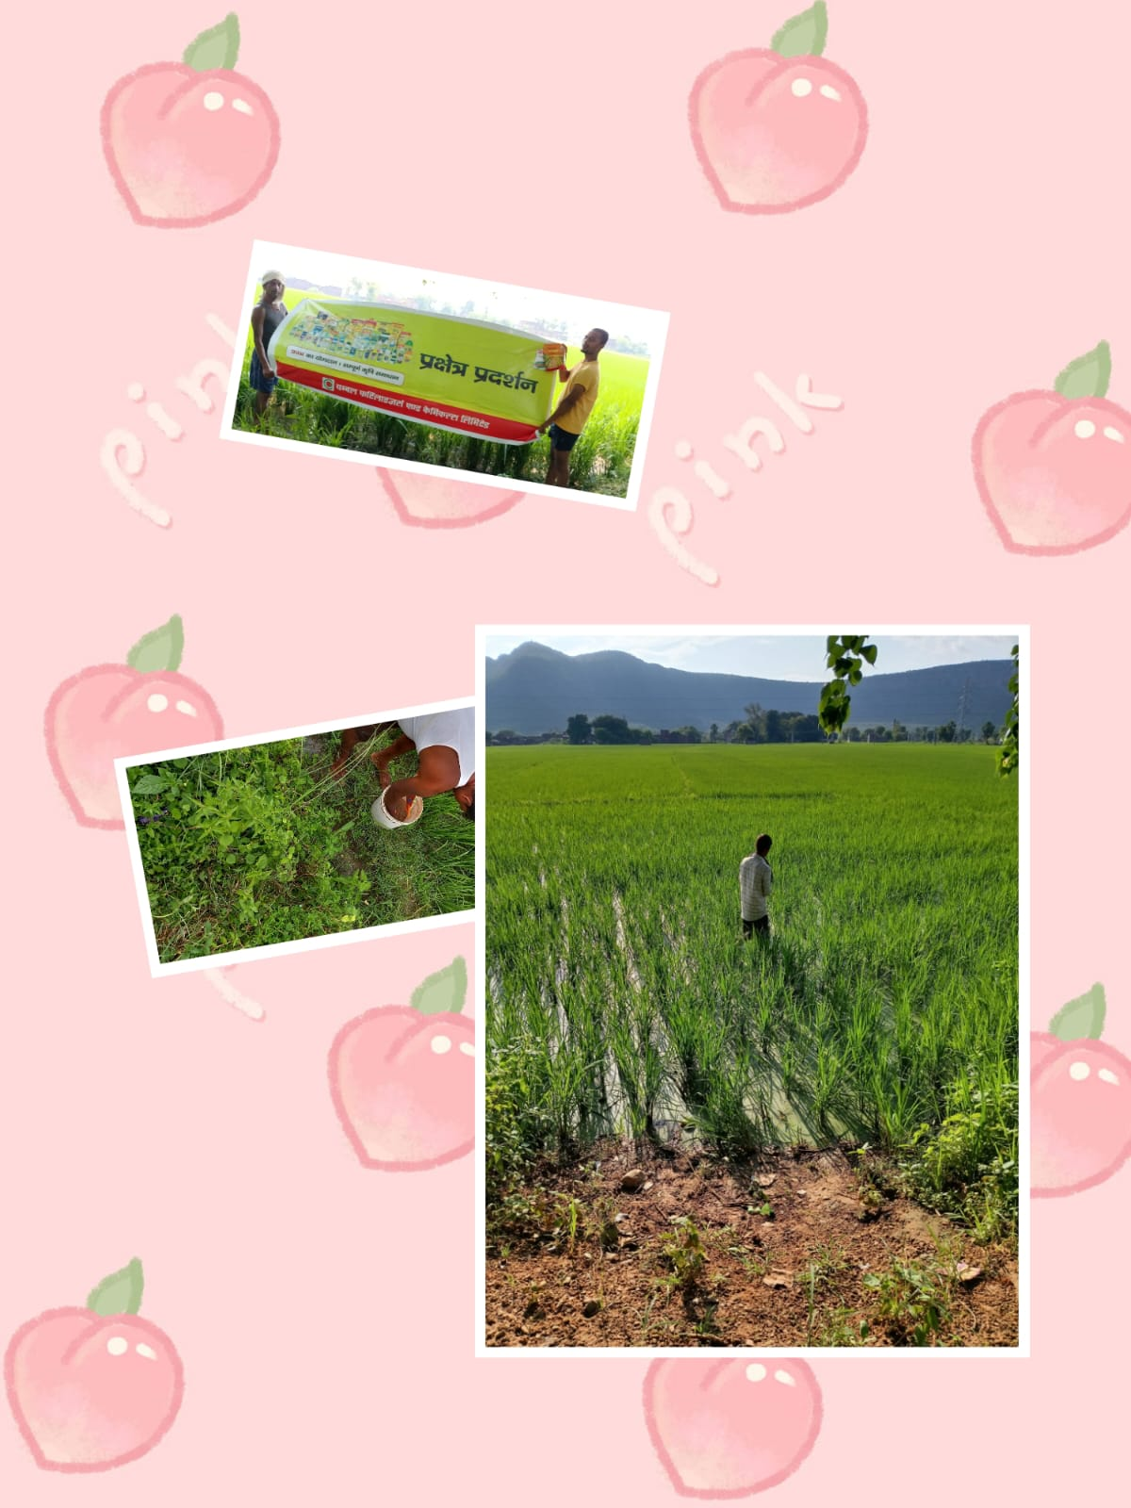

COMBO DEMONSTRATION REPORT – 5
Seed to Harvest
Details Of Farmer
Name of Farmers | Krishna Chaurasiya
Mobile No. | +918789813952
Village Name | Shahpur
Block & Tehsil | Chenari
District & State | ROHTASH

Field And Crop Detail
Total Acreage(acre) | 12 ACRE
Crops Grown | 12 ACRE
Field Location (Easy approach/road side) | EASY APPROCH
Selected - Crop & Variety | PADDY MTU-7029
Trial Plot Area (KATHA) | 32KATHA (INCULDING T1+ T2+ T3)
Seed Rate (kg/acre) | 3 KG/ACRE
Sowing Date | 21.07.2025

Demo Product Name And Dose& Field day detail
Name of Product | SULFINO GOLD
Application Dose (ml/acre) | 1.5 KG
Date/Time of Application | 30.08.2025

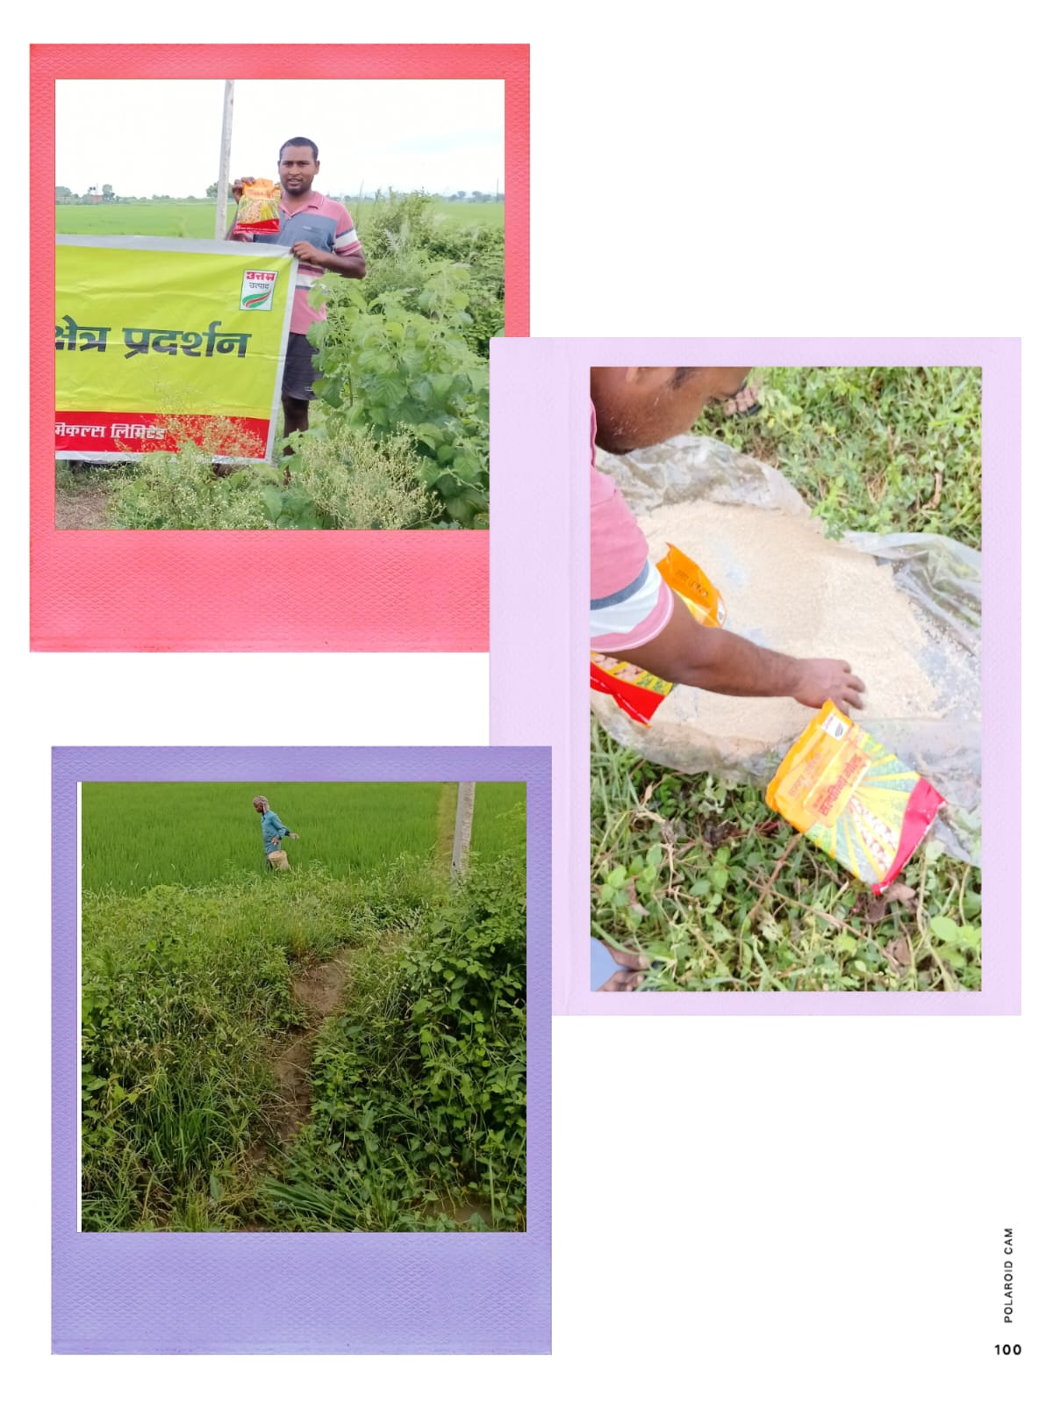

COMBO DEMONSTRATION REPORT – 6
Seed to Harvest
Details Of Farmer
Name of Farmers | Guddu Singh
Mobile No. | 9608990112
Village Name | Rendia
Block & Tehsil | Chenari
District & State | ROHTASH

Field And Crop Detail
Total Acreage(acre) | 12 ACRE
Crops Grown | 12 ACRE
Field Location (Easy approach/road side) | ROAD SIDE
Selected - Crop & Variety | PADDY MTU-7029
Trial Plot Area (KATHA) | 32 KATHA (INCULDING T1+ T2+ T3)
Seed Rate (kg/acre) | 3 KG/ACRE
Sowing Date | 22.07.2025

Demo Product Name And Dose& Field day detail
Name of Product | SULFINO GOLD
Application Dose (ml/acre) | 1.5 KG
Date/Time of Application | 28.08.2025

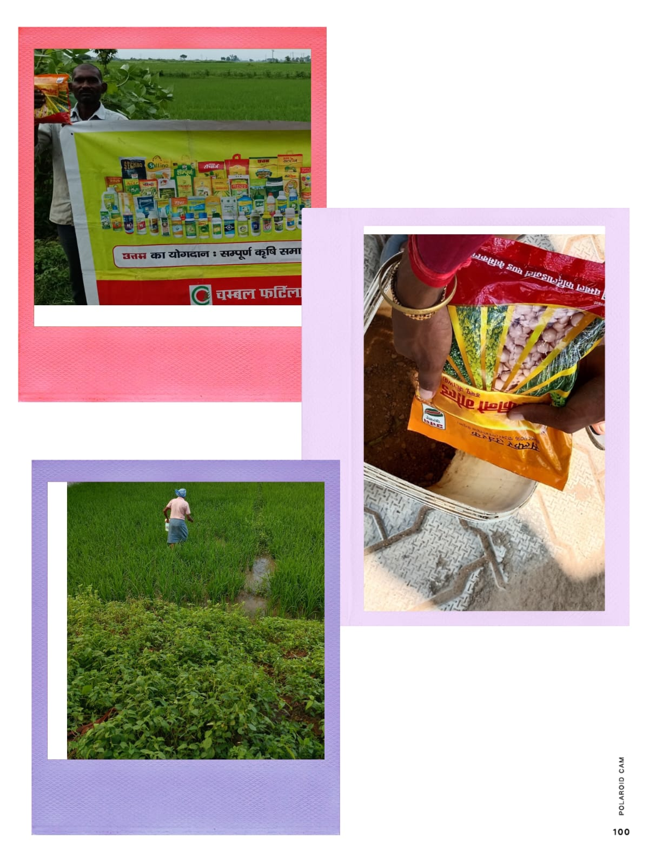

COMBO DEMONSTRATION REPORT – 7
Seed to Harvest
Details Of Farmer
Name of Farmers | Kamlesh Tiwari
Mobile No. | +919523804892
Village Name | Tenduni
Block & Tehsil | Chenari
District & State | ROHTASH

Field And Crop Detail
Total Acreage(acre) | 05 ACRE
Crops Grown | 05 ACRE
Field Location (Easy approach/road side) | EASY APPROACH
Selected - Crop & Variety | PADDY MTU-7029
Trial Plot Area (KATHA) | 32KATHA (INCULDING T1+ T2+ T3)
Seed Rate (kg/acre) | 3 KG/ACRE
Sowing Date | 22.07.2025

Demo Product Name And Dose& Field day detail
Name of Product | SULFINO GOLD
Application Dose (ml/acre) | 1.5 KG
Date/Time of Application | 30.08.2025
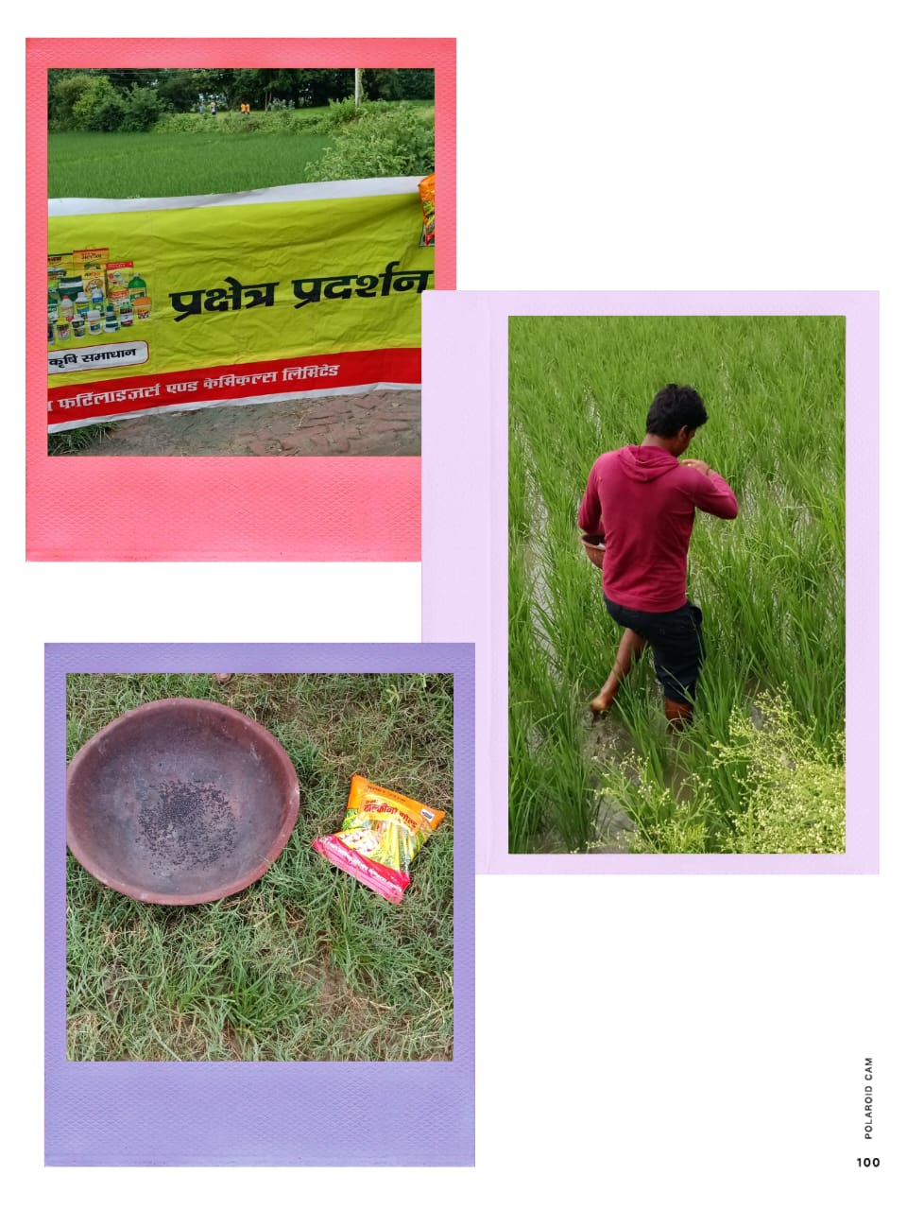

COMBO DEMONSTRATION REPORT – 8
Seed to Harvest
Details Of Farmer
Name of Farmers | Mahendar Singh
Mobile No. | 93346 15140
Village Name | Chanka
Block & Tehsil | Nokha
District & State | ROHTASH

Field And Crop Detail
Total Acreage(acre) | 10 ACRE
Crops Grown | 10 ACRE
Field Location (Easy approach/road side) | ROAD SIDE
Selected - Crop & Variety | PADDY MTU-7029
Trial Plot Area (KATHA) | 18 KATHA (INCULDING T1+ T2+ T3)
Seed Rate (kg/acre) | 3 KG/ACRE
Sowing Date | 25.07.2025

Demo Product Name And Dose& Field day detail
Name of Product | SULFINO GOLD
Application Dose (ml/acre) | 600 GM
Date/Time of Application | 31.08.2025
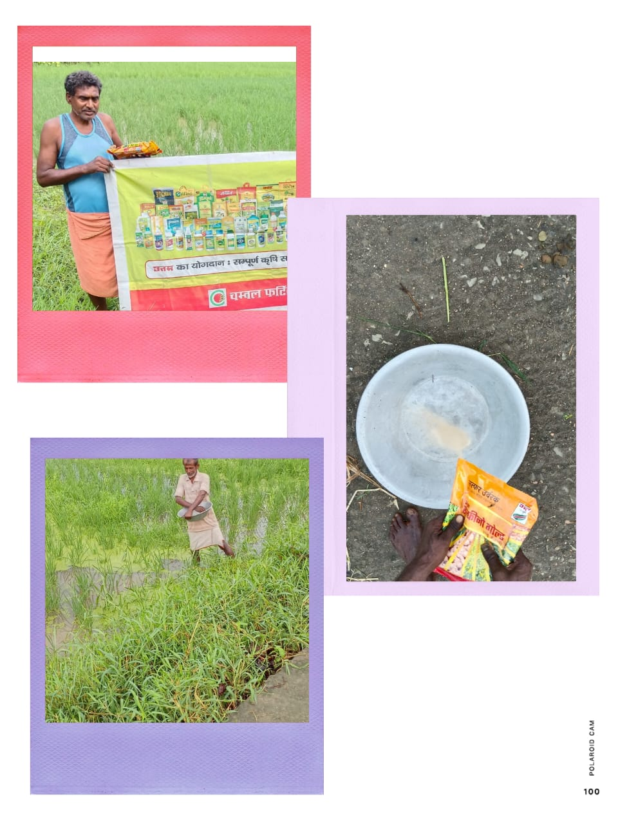

COMBO DEMONSTRATION REPORT – 9
Seed to Harvest
Details Of Farmer
Name of Farmers | Alok Kumar
Mobile No. | +919135569285
Village Name | Kushdihra
Block & Tehsil | Tilouthu
District & State | ROHTASH

Field And Crop Detail
Total Acreage(acre) | 07 ACRE
Crops Grown | 07 ACRE
Field Location (Easy approach/road side) | EASY APPROCH
Selected - Crop & Variety | PADDY MTU-7029
Trial Plot Area (KATHA) | 18 KATHA (INCULDING T1+ T2+ T3)
Seed Rate (kg/acre) | 3 KG/ACRE
Sowing Date | 25.07.2025

Demo Product Name And Dose& Field day detail
Name of Product | SULFINO GOLD
Application Dose (ml/acre) | 600 GM/ACRE
Date/Time of Application | 25.08.2025

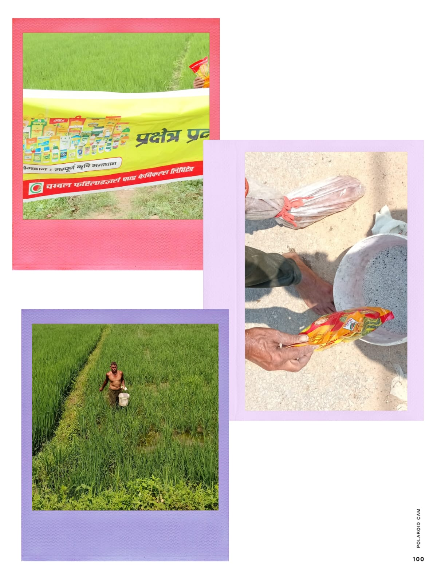

COMBO DEMONSTRATION REPORT – 10
Seed to Harvest
Details Of Farmer
Name of Farmers | Nijamudin Ansari
Mobile No. | 6207506007
Village Name | Baradih
Block & Tehsil | Tilouthu
District & State | ROHTASH

Field And Crop Detail
Total Acreage(acre) | 8 ACRE
Crops Grown | 8 ACRE
Field Location (Easy approach/road side) | EASY APPROCH
Selected - Crop & Variety | PADDY MTU-7029
Trial Plot Area (KATHA) | 32 KATHA (INCULDING T1+ T2+ T3)
Seed Rate (kg/acre) | 3 KG/ACRE
Sowing Date | 04.07.2025

Demo Product Name And Dose& Field day detail
Name of Product | SULFINO GOLD
Application Dose (ml/acre) | 1.5 KG
Date/Time of Application | 20.08.2025
